|  |  |
| --- | --- |
| Faculty of Engineering & Technology  Ramaiah University of Applied Sciences | |
| Laboratory Examination Report – M. Tech. | |
| Department | Electronic and Communication Engineering |
| Course | MTech in Machine learning and intelligent systems |
| Batch | Full Time 2017 |
| Module Code | MIS503 |
| Module Title | Probalistic Graphical models |
| Name | Vishnu Prasad P |
| Reg. No. | 17ETCS075004 |
| Date | 14/07/2018 |
|  |  |

**Q 1**

**a)Perform suitable text pre-processing and POS tagging**

Pre-processing

* The given text is tokenised into words and sentences for the further processing tasks.

**Sentence Tokenisation Output**

['A strike by farmers in Maharashtra continues to affect normal life, despite the State governmentís announcement of an end to the strike last week.', 'The farmers, whose demands include full waiver of farm loans, hikes in the minimum support price for agricultural produce and writing off of pending electricity bills, have been on an indefinite strike since June 1.', 'As the strike nears the end of its first week, prices of essential goods such as milk, fruits and vegetables have risen steeply, causing distress to consumers.', 'Some farmer groups agreed to call off their strike after Chief Minister Devendra Fadnavis promised that his government would waive farm loans of small and marginal farmers worth about ?30,000 crore, increase power subsidies, hike the price for milk procurement, and also set up a State commission to look into the matter of raising the MSP for crops.', 'He also promised that buying agricultural produce below their MSP would soon be made a criminal offence.', 'Other farmer groups, meanwhile, have stuck to their demand for a complete farm loan waiver and continued with their protest.', 'It is notable that the protests have come soon after the Uttar Pradesh government waived farm loans earlier this year, setting off similar demands in other States.', 'Yet, while Maharashtraís farmers have caught the attention of the government, the focus on quick fixes has pushed aside the real structural issues behind the crisis.', 'At the root of the crisis is the steep fall in the prices of agricultural goods.', 'The price slump, significantly, has come against the backdrop of a good monsoon that led to a bumper crop.', 'The production of tur dal, for instance, increased five-fold from last year to over 20 lakh tonnes in 2016-17.', 'Irrespective of price fluctuations, MSPs are supposed to enable farmers to sell their produce at remunerative prices.', 'But procurement of crops at MSP by the government has traditionally been low for most crops, except a few staples such as rice and wheat.', 'This has forced distressed farmers to sell their produce at much lower prices, adding to their debt burden.', 'Not surprisingly, the whole system of agricultural marketing has led farmers to feel cheated, and it was only a matter of time before they organised themselves to protest.', 'Going forward, any long-term, wide-scale procurement of crops at MSPs looks unlikely; even a one-time full loan waiver is considered unrealistic by the Chief Minister, given the Stateís finances.', 'The possible ban on buying produce below the MSP would just worsen the crisis by making it hard for farmers to sell their produce even at the market price.', 'The only long-term solution is to gradually align crop production with genuine price signals, while moving ahead with reforms to de-risk agriculture, especially by increasing the crop insurance cover.', 'Expediting steps to reform the Agricultural Produce Market Committee system and introduce the model contract farming law would go a long way to free farmers from MSP-driven crop planning.']

**Word Tokenisation Output**

['A', 'strike', 'by', 'farmers', 'in', 'Maharashtra', 'continues', 'to', 'affect', 'normal', 'life', ',', 'despite', 'the', 'State', 'governmentís', 'announcement', 'of', 'an', 'end', 'to', 'the', 'strike', 'last', 'week', '.', 'The', 'farmers', ',', 'whose', 'demands', 'include', 'full', 'waiver', 'of', 'farm', 'loans', ',', 'hikes', 'in', 'the', 'minimum', 'support', 'price', 'for', 'agricultural', 'produce', 'and', 'writing', 'off', 'of', 'pending', 'electricity', 'bills', ',', 'have', 'been', 'on', 'an', 'indefinite', 'strike', 'since', 'June', '1', '.', 'As', 'the', 'strike', 'nears', 'the', 'end', 'of', 'its', 'first', 'week', ',', 'prices', 'of', 'essential', 'goods', 'such', 'as', 'milk', ',', 'fruits', 'and', 'vegetables', 'have', 'risen', 'steeply', ',', 'causing', 'distress', 'to', 'consumers', '.', 'Some', 'farmer', 'groups', 'agreed', 'to', 'call', 'off', 'their', 'strike', 'after', 'Chief', 'Minister', 'Devendra', 'Fadnavis', 'promised', 'that', 'his', 'government', 'would', 'waive', 'farm', 'loans', 'of', 'small', 'and', 'marginal', 'farmers', 'worth', 'about', '?', '30,000', 'crore', ',', 'increase', 'power', 'subsidies', ',', 'hike', 'the', 'price', 'for', 'milk', 'procurement', ',', 'and', 'also', 'set', 'up', 'a', 'State', 'commission', 'to', 'look', 'into', 'the', 'matter', 'of', 'raising', 'the', 'MSP', 'for', 'crops', '.', 'He', 'also', 'promised', 'that', 'buying', 'agricultural', 'produce', 'below', 'their', 'MSP', 'would', 'soon', 'be', 'made', 'a', 'criminal', 'offence', '.', 'Other', 'farmer', 'groups', ',', 'meanwhile', ',', 'have', 'stuck', 'to', 'their', 'demand', 'for', 'a', 'complete', 'farm', 'loan', 'waiver', 'and', 'continued', 'with', 'their', 'protest', '.', 'It', 'is', 'notable', 'that', 'the', 'protests', 'have', 'come', 'soon', 'after', 'the', 'Uttar', 'Pradesh', 'government', 'waived', 'farm', 'loans', 'earlier', 'this', 'year', ',', 'setting', 'off', 'similar', 'demands', 'in', 'other', 'States', '.', 'Yet', ',', 'while', 'Maharashtraís', 'farmers', 'have', 'caught', 'the', 'attention', 'of', 'the', 'government', ',', 'the', 'focus', 'on', 'quick', 'fixes', 'has', 'pushed', 'aside', 'the', 'real', 'structural', 'issues', 'behind', 'the', 'crisis', '.', 'At', 'the', 'root', 'of', 'the', 'crisis', 'is', 'the', 'steep', 'fall', 'in', 'the', 'prices', 'of', 'agricultural', 'goods', '.', 'The', 'price', 'slump', ',', 'significantly', ',', 'has', 'come', 'against', 'the', 'backdrop', 'of', 'a', 'good', 'monsoon', 'that', 'led', 'to', 'a', 'bumper', 'crop', '.', 'The', 'production', 'of', 'tur', 'dal', ',', 'for', 'instance', ',', 'increased', 'five-fold', 'from', 'last', 'year', 'to', 'over', '20', 'lakh', 'tonnes', 'in', '2016-17', '.', 'Irrespective', 'of', 'price', 'fluctuations', ',', 'MSPs', 'are', 'supposed', 'to', 'enable', 'farmers', 'to', 'sell', 'their', 'produce', 'at', 'remunerative', 'prices', '.', 'But', 'procurement', 'of', 'crops', 'at', 'MSP', 'by', 'the', 'government', 'has', 'traditionally', 'been', 'low', 'for', 'most', 'crops', ',', 'except', 'a', 'few', 'staples', 'such', 'as', 'rice', 'and', 'wheat', '.', 'This', 'has', 'forced', 'distressed', 'farmers', 'to', 'sell', 'their', 'produce', 'at', 'much', 'lower', 'prices', ',', 'adding', 'to', 'their', 'debt', 'burden', '.', 'Not', 'surprisingly', ',', 'the', 'whole', 'system', 'of', 'agricultural', 'marketing', 'has', 'led', 'farmers', 'to', 'feel', 'cheated', ',', 'and', 'it', 'was', 'only', 'a', 'matter', 'of', 'time', 'before', 'they', 'organised', 'themselves', 'to', 'protest', '.', 'Going', 'forward', ',', 'any', 'long-term', ',', 'wide-scale', 'procurement', 'of', 'crops', 'at', 'MSPs', 'looks', 'unlikely', ';', 'even', 'a', 'one-time', 'full', 'loan', 'waiver', 'is', 'considered', 'unrealistic', 'by', 'the', 'Chief', 'Minister', ',', 'given', 'the', 'Stateís', 'finances', '.', 'The', 'possible', 'ban', 'on', 'buying', 'produce', 'below', 'the', 'MSP', 'would', 'just', 'worsen', 'the', 'crisis', 'by', 'making', 'it', 'hard', 'for', 'farmers', 'to', 'sell', 'their', 'produce', 'even', 'at', 'the', 'market', 'price', '.', 'The', 'only', 'long-term', 'solution', 'is', 'to', 'gradually', 'align', 'crop', 'production', 'with', 'genuine', 'price', 'signals', ',', 'while', 'moving', 'ahead', 'with', 'reforms', 'to', 'de-risk', 'agriculture', ',', 'especially', 'by', 'increasing', 'the', 'crop', 'insurance', 'cover', '.', 'Expediting', 'steps', 'to', 'reform', 'the', 'Agricultural', 'Produce', 'Market', 'Committee', 'system', 'and', 'introduce', 'the', 'model', 'contract', 'farming', 'law', 'would', 'go', 'a', 'long', 'way', 'to', 'free', 'farmers', 'from', 'MSP-driven', 'crop', 'planning', '.']

* Before the POS tagging all the stop words like ‘the’, ‘is’, ‘are’ are eliminated.
* The POS tagger is run over the cleaned words.

**POS tagger Output**

[('A', 'DT'), ('strike', 'NN'), ('farmers', 'NNS'), ('Maharashtra', 'NNP'), ('continues', 'VBZ'), ('affect', 'VB'), ('normal', 'JJ'), ('life', 'NN'), (',', ','), ('despite', 'IN'), ('State', 'NNP'), ('governmentís', 'VBD'), ('announcement', 'NN'), ('end', 'NN'), ('strike', 'NN'), ('last', 'JJ'), ('week', 'NN'), ('.', '.')]

[('The', 'DT'), ('farmers', 'NNS'), (',', ','), ('whose', 'WP$'), ('demands', 'NNS'), ('include', 'VBP'), ('full', 'JJ'), ('waiver', 'NN'), ('farm', 'NN'), ('loans', 'NNS'), (',', ','), ('hikes', 'NNS'), ('minimum', 'JJ'), ('support', 'NN'), ('price', 'NN'), ('agricultural', 'JJ'), ('produce', 'NN'), ('writing', 'VBG'), ('pending', 'VBG'), ('electricity', 'NN'), ('bills', 'NNS'), (',', ','), ('indefinite', 'RB'), ('strike', 'NN'), ('since', 'IN'), ('June', 'NNP'), ('1', 'CD'), ('.', '.')]

[('As', 'IN'), ('strike', 'NN'), ('nears', 'NNS'), ('end', 'VBP'), ('first', 'JJ'), ('week', 'NN'), (',', ','), ('prices', 'NNS'), ('essential', 'JJ'), ('goods', 'NNS'), ('milk', 'NN'), (',', ','), ('fruits', 'NNS'), ('vegetables', 'NNS'), ('risen', 'VBP'), ('steeply', 'RB'), (',', ','), ('causing', 'VBG'), ('distress', 'NN'), ('consumers', 'NNS'), ('.', '.')]

[('Some', 'DT'), ('farmer', 'NN'), ('groups', 'NNS'), ('agreed', 'VBD'), ('call', 'NN'), ('strike', 'NN'), ('Chief', 'NNP'), ('Minister', 'NNP'), ('Devendra', 'NNP'), ('Fadnavis', 'NNP'), ('promised', 'VBD'), ('government', 'NN'), ('would', 'MD'), ('waive', 'VB'), ('farm', 'NN'), ('loans', 'NNS'), ('small', 'JJ'), ('marginal', 'JJ'), ('farmers', 'NNS'), ('worth', 'IN'), ('?', '.'), ('30,000', 'CD'), ('crore', 'NN'), (',', ','), ('increase', 'VB'), ('power', 'NN'), ('subsidies', 'NNS'), (',', ','), ('hike', 'JJ'), ('price', 'NN'), ('milk', 'NN'), ('procurement', 'NN'), (',', ','), ('also', 'RB'), ('set', 'VBN'), ('State', 'NNP'), ('commission', 'NN'), ('look', 'NN'), ('matter', 'NN'), ('raising', 'VBG'), ('MSP', 'NNP'), ('crops', 'NNS'), ('.', '.')]

[('He', 'PRP'), ('also', 'RB'), ('promised', 'VBD'), ('buying', 'VBG'), ('agricultural', 'JJ'), ('produce', 'NN'), ('MSP', 'NNP'), ('would', 'MD'), ('soon', 'RB'), ('made', 'VB'), ('criminal', 'JJ'), ('offence', 'NN'), ('.', '.')]

[('Other', 'JJ'), ('farmer', 'NN'), ('groups', 'NNS'), (',', ','), ('meanwhile', 'RB'), (',', ','), ('stuck', 'JJ'), ('demand', 'NN'), ('complete', 'JJ'), ('farm', 'NN'), ('loan', 'NN'), ('waiver', 'WDT'), ('continued', 'VBD'), ('protest', 'JJS'), ('.', '.')]

[('It', 'PRP'), ('notable', 'JJ'), ('protests', 'NNS'), ('come', 'VBP'), ('soon', 'RB'), ('Uttar', 'NNP'), ('Pradesh', 'NNP'), ('government', 'NN'), ('waived', 'VBD'), ('farm', 'NN'), ('loans', 'NNS'), ('earlier', 'RBR'), ('year', 'NN'), (',', ','), ('setting', 'VBG'), ('similar', 'JJ'), ('demands', 'NNS'), ('States', 'NNPS'), ('.', '.')]

[('Yet', 'RB'), (',', ','), ('Maharashtraís', 'NNP'), ('farmers', 'NNS'), ('caught', 'VBD'), ('attention', 'NN'), ('government', 'NN'), (',', ','), ('focus', 'VB'), ('quick', 'JJ'), ('fixes', 'NNS'), ('pushed', 'VBD'), ('aside', 'RB'), ('real', 'JJ'), ('structural', 'JJ'), ('issues', 'NNS'), ('behind', 'IN'), ('crisis', 'NN'), ('.', '.')]

[('At', 'IN'), ('root', 'NN'), ('crisis', 'NN'), ('steep', 'JJ'), ('fall', 'NN'), ('prices', 'NNS'), ('agricultural', 'JJ'), ('goods', 'NNS'), ('.', '.')]

[('The', 'DT'), ('price', 'NN'), ('slump', 'NN'), (',', ','), ('significantly', 'RB'), (',', ','), ('come', 'VB'), ('backdrop', 'NN'), ('good', 'JJ'), ('monsoon', 'NN'), ('led', 'VBD'), ('bumper', 'JJR'), ('crop', 'NN'), ('.', '.')]

[('The', 'DT'), ('production', 'NN'), ('tur', 'NN'), ('dal', 'NN'), (',', ','), ('instance', 'NN'), (',', ','), ('increased', 'VBD'), ('five-fold', 'NN'), ('last', 'JJ'), ('year', 'NN'), ('20', 'CD'), ('lakh', 'NN'), ('tonnes', 'NNS'), ('2016-17', 'CD'), ('.', '.')]

[('Irrespective', 'JJ'), ('price', 'NN'), ('fluctuations', 'NNS'), (',', ','), ('MSPs', 'NNP'), ('supposed', 'VBD'), ('enable', 'JJ'), ('farmers', 'NNS'), ('sell', 'VBP'), ('produce', 'VBP'), ('remunerative', 'JJ'), ('prices', 'NNS'), ('.', '.')]

[('But', 'CC'), ('procurement', 'JJ'), ('crops', 'NNS'), ('MSP', 'JJ'), ('government', 'NN'), ('traditionally', 'RB'), ('low', 'JJ'), ('crops', 'NNS'), (',', ','), ('except', 'IN'), ('staples', 'NNS'), ('rice', 'RB'), ('wheat', 'NN'), ('.', '.')]

[('This', 'DT'), ('forced', 'VBD'), ('distressed', 'JJ'), ('farmers', 'NNS'), ('sell', 'VBP'), ('produce', 'RB'), ('much', 'JJ'), ('lower', 'JJR'), ('prices', 'NNS'), (',', ','), ('adding', 'VBG'), ('debt', 'NN'), ('burden', 'NN'), ('.', '.')]

[('Not', 'RB'), ('surprisingly', 'RB'), (',', ','), ('whole', 'JJ'), ('system', 'NN'), ('agricultural', 'JJ'), ('marketing', 'NN'), ('led', 'VBD'), ('farmers', 'NNS'), ('feel', 'VBP'), ('cheated', 'VBN'), (',', ','), ('matter', 'NN'), ('time', 'NN'), ('organised', 'VBN'), ('protest', 'NN'), ('.', '.')]

[('Going', 'VBG'), ('forward', 'RB'), (',', ','), ('long-term', 'JJ'), (',', ','), ('wide-scale', 'JJ'), ('procurement', 'NN'), ('crops', 'NNS'), ('MSPs', 'NNP'), ('looks', 'VBZ'), ('unlikely', 'JJ'), (';', ':'), ('even', 'RB'), ('one-time', 'VBP'), ('full', 'JJ'), ('loan', 'NN'), ('waiver', 'NN'), ('considered', 'VBN'), ('unrealistic', 'JJ'), ('Chief', 'NNP'), ('Minister', 'NNP'), (',', ','), ('given', 'VBN'), ('Stateís', 'NNP'), ('finances', 'NNS'), ('.', '.')]

[('The', 'DT'), ('possible', 'JJ'), ('ban', 'NN'), ('buying', 'NN'), ('produce', 'NN'), ('MSP', 'NNP'), ('would', 'MD'), ('worsen', 'VB'), ('crisis', 'NN'), ('making', 'VBG'), ('hard', 'JJ'), ('farmers', 'NNS'), ('sell', 'VBP'), ('produce', 'VB'), ('even', 'RB'), ('market', 'NN'), ('price', 'NN'), ('.', '.')]

[('The', 'DT'), ('long-term', 'JJ'), ('solution', 'NN'), ('gradually', 'RB'), ('align', 'JJ'), ('crop', 'NN'), ('production', 'NN'), ('genuine', 'JJ'), ('price', 'NN'), ('signals', 'NNS'), (',', ','), ('moving', 'VBG'), ('ahead', 'RB'), ('reforms', 'NNS'), ('de-risk', 'JJ'), ('agriculture', 'NN'), (',', ','), ('especially', 'RB'), ('increasing', 'VBG'), ('crop', 'NN'), ('insurance', 'NN'), ('cover', 'NN'), ('.', '.')]

[('Expediting', 'VBG'), ('steps', 'NNS'), ('reform', 'RB'), ('Agricultural', 'NNP'), ('Produce', 'NNP'), ('Market', 'NNP'), ('Committee', 'NNP'), ('system', 'NN'), ('introduce', 'VBP'), ('model', 'NN'), ('contract', 'NN'), ('farming', 'JJ'), ('law', 'NN'), ('would', 'MD'), ('go', 'VB'), ('long', 'JJ'), ('way', 'NN'), ('free', 'JJ'), ('farmers', 'NNS'), ('MSP-driven', 'JJ'), ('crop', 'NN'), ('planning', 'NN'), ('.', '.')]

**b)Noun to noun mapping**

In the noun to noun mapping the action perform is of, if a word in the sentence starts with the noun and is connected with in/of/etc... and connected to another noun in the same sentence those two words are given as an output this is achieved by the grammar that is fed to the regex parser

This tells us the relation of all the relation of nouns Ex:relation of person and the place in the sentence.

strike

farmer

maharashtra

life

state

governmentí

announc

end

strike

week

farmer

demand

waiver

farm

loan

hike

support

price

produc

electr

bill

indefinit

strike

june

strike

end

week

price

good

milk

fruit

veget

distress

consum

farmer

group

strike

chief

minist

devendra

fadnavi

govern

farm

loan

farmer

crore

power

subsidi

price

milk

procur

state

commiss

matter

msp

crop

produc

msp

offenc

farmer

group

demand

farm

loan

waiver

protest

protest

uttar

pradesh

govern

farm

loan

year

demand

state

maharashtraí

farmer

attent

govern

focu

fix

issu

crisi

root

crisi

fall

price

good

price

slump

backdrop

monsoon

bumper

crop

product

tur

dal

instanc

five-fold

year

tonn

irrespect

price

fluctuat

msp

farmer

produc

price

procur

crop

msp

govern

crop

stapl

rice

wheat

farmer

produc

price

debt

burden

system

market

farmer

matter

time

procur

crop

msp

loan

waiver

chief

minist

stateí

financ

ban

produc

msp

crisi

farmer

produc

market

price

solut

crop

product

price

signal

reform

agricultur

crop

insur

cover

step

agricultur

produc

market

committe

system

model

contract

law

way

farmer

msp-driven

crop

plan

**c)Noun to verb mapping**

This tells us the relation of all the action taken by a noun Ex:relation of person(Noun) protesting(Verb) in the sentence.

strike

farmer

maharashtra

affect

life

state

governmentí

announc

end

strike

week

farmer

demand

waiver

farm

loan

hike

support

price

produc

electr

bill

indefinit

strike

june

strike

end

week

price

good

milk

fruit

veget

distress

consum

farmer

group

call

strike

chief

minist

devendra

fadnavi

govern

waiv

farm

loan

farmer

crore

increas

power

subsidi

hike

price

milk

procur

state

commiss

look

matter

msp

crop

produc

msp

offenc

farmer

group

demand

farm

loan

waiver

protest

protest

uttar

pradesh

govern

farm

loan

year

demand

state

maharashtraí

farmer

attent

govern

focu

fix

issu

crisi

root

crisi

fall

price

good

price

slump

backdrop

monsoon

bumper

crop

product

tur

dal

instanc

five-fold

year

tonn

irrespect

price

fluctuat

msp

enabl

farmer

sell

produc

price

procur

crop

msp

govern

crop

stapl

rice

wheat

farmer

sell

produc

price

debt

burden

system

market

farmer

feel

matter

time

protest

procur

crop

msp

loan

waiver

chief

minist

stateí

financ

ban

produc

msp

worsen

crisi

farmer

sell

produc

market

price

solut

align

crop

product

price

signal

reform

agricultur

crop

insur

cover

step

reform

agricultur

produc

market

committe

system

introduc

model

contract

law

go

way

farmer

msp-driven

crop

plan

**d)Develop a Bayesian network**

Here the Bayesian network is developed for the first paragraph.

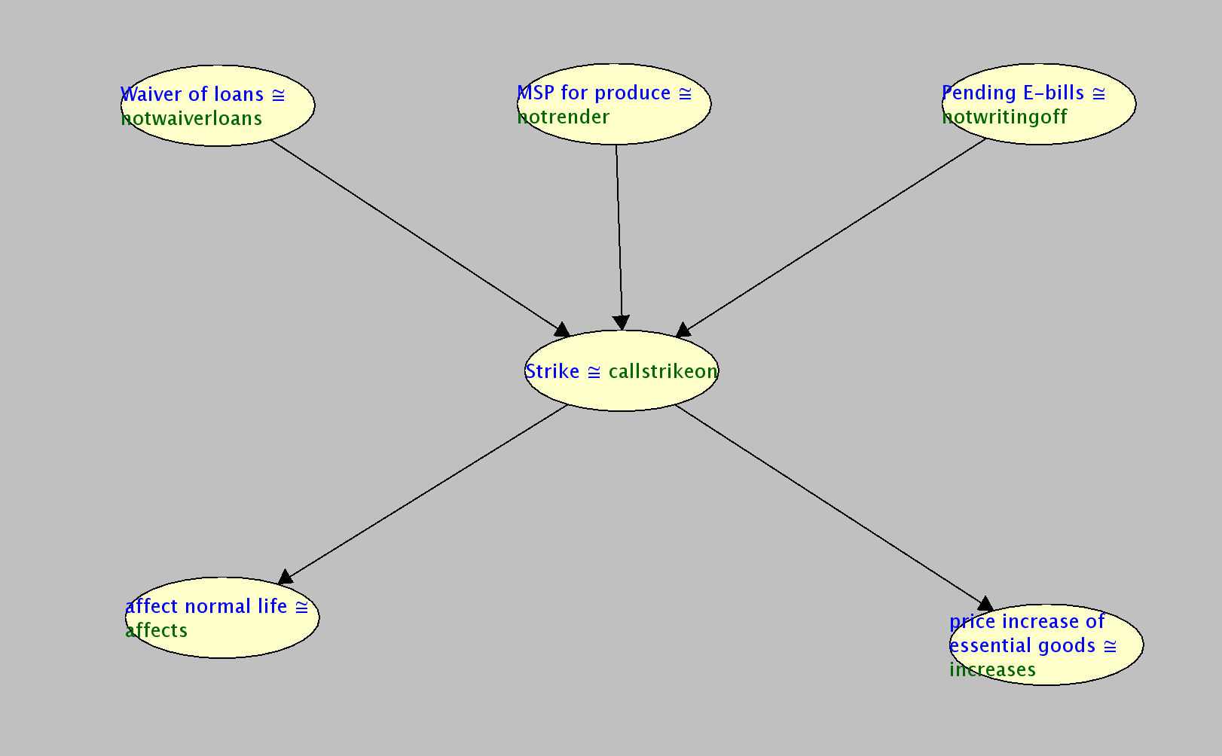

Figure1‑1:Bayesian network of the first paragraph

**d)** **Analyse the conditional probability distribution for any two nodes.**

* Analysis with respect to the cause for the strike

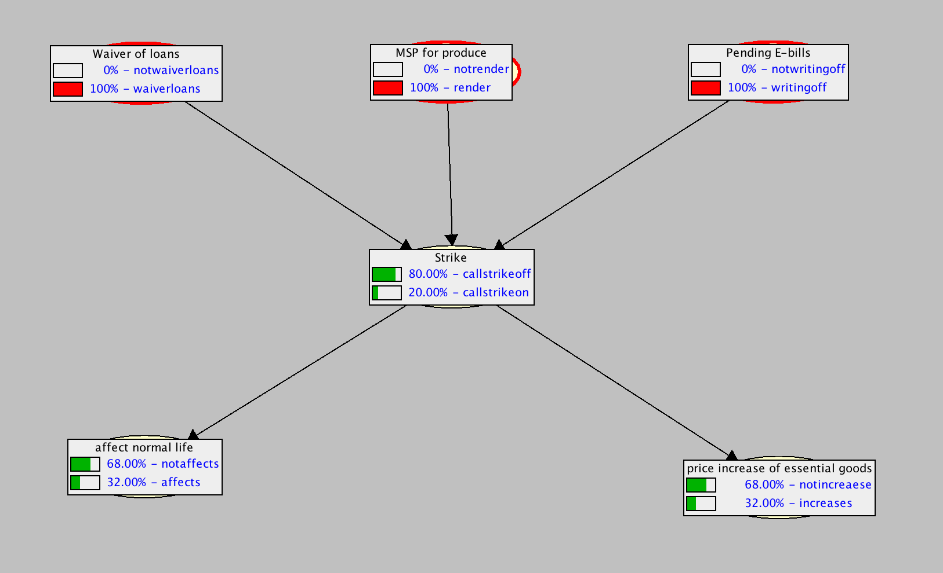

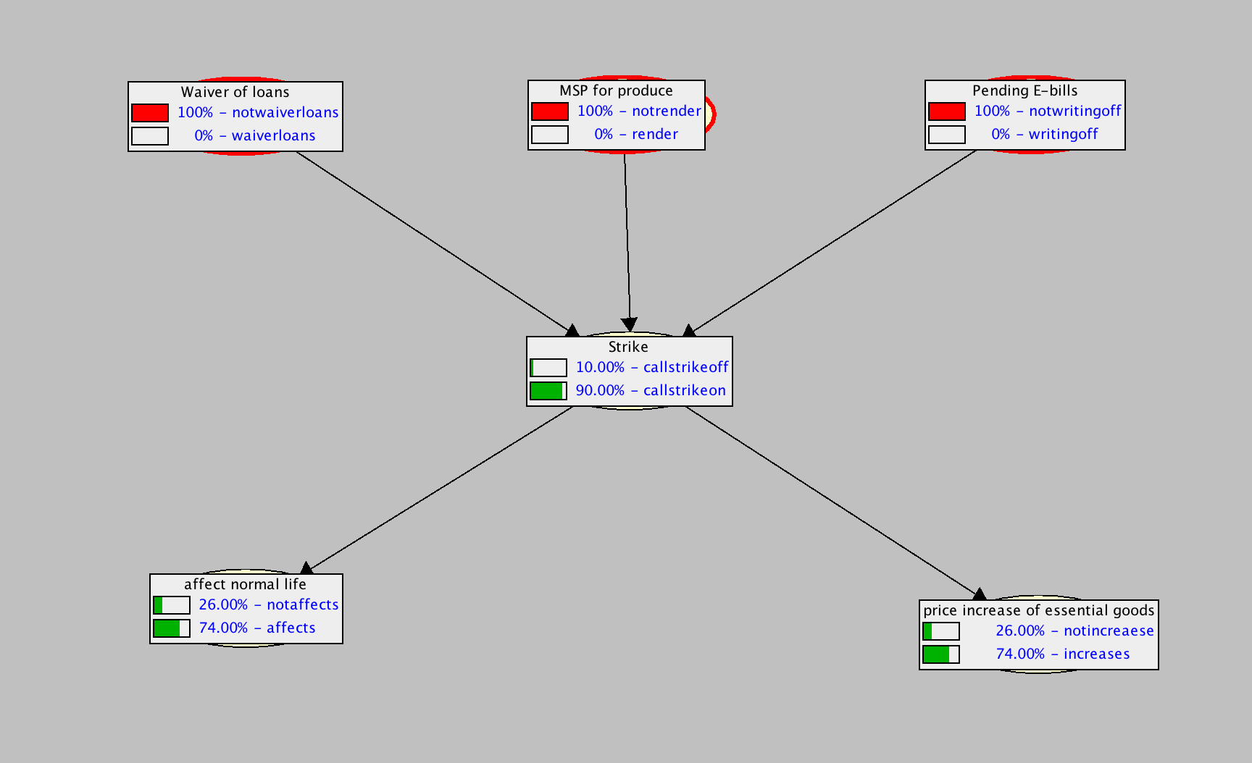

* Analysis with respect to the affects of the strike

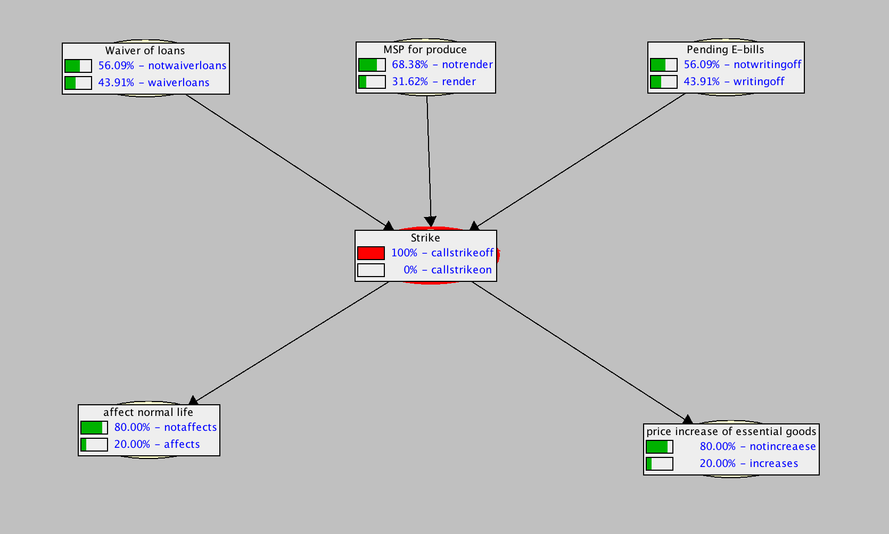

s